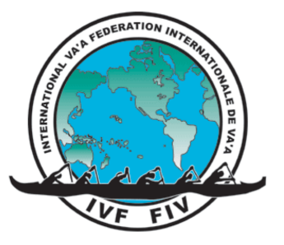
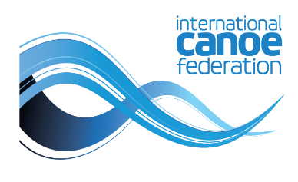
IVF PARA VA’A PADDLER
CERTIFICATE OF DIAGNOSIS
Please note this form must be completed in English
The person below is required to undergo ICF/IVF Paracanoe Athlete Classification to compete at the International level of their chosen sport. To assist the classification process a confirmation of the medical diagnosis is required. (The ICF acknowledges the work of the IVF Adaptive paddling program in developing this document.)

Family Name: Given Name:

Sex: M F Date of Birth: (day/month/year)

Country

Athlete signature

Medical details (This section must only be completed by a medical doctor)

Athlete diagnosis

How long has the athlete had this condition?

Is the condition: Stable? Deteriorating? Fluctuating
(Please tick one box)

Are there any other factors which
may affect the athletes fitness for
competition? Eg: epilepsy, diabetes,
heart disease, cancer, severe allergies,
high blood pressure

Declaration

I hereby certify that I have known this patient for years and certify that the above named patient has the stated diagnosis.
Doctors Signature

Doctors Name
(Please Print)

Address

